1. **Member – Mobile user guide**
   1. **Login**

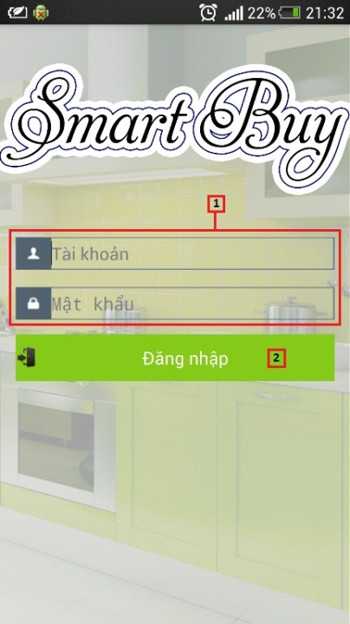

|  |  |
| --- | --- |
| **Step** | **Description** |
| 1 | Fill Username and Password |
| 2 | Click button “Đăng nhập” |

* 1. **View favourite product**

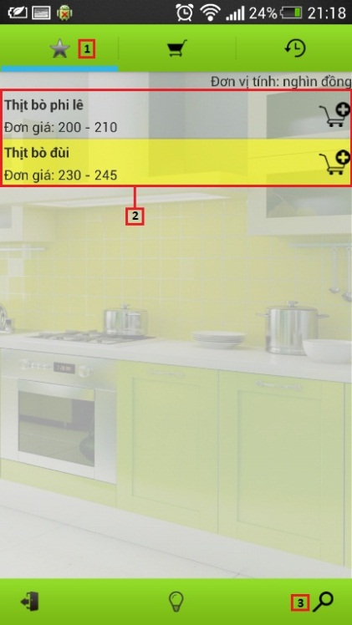

|  |  |
| --- | --- |
| **Step** | **Description** |
| 1 | Click icon  to view favourite product |
| 2 | View favourite product list (product name, price) |
| 3 | Click icon  to search product |

* 1. **Search product**

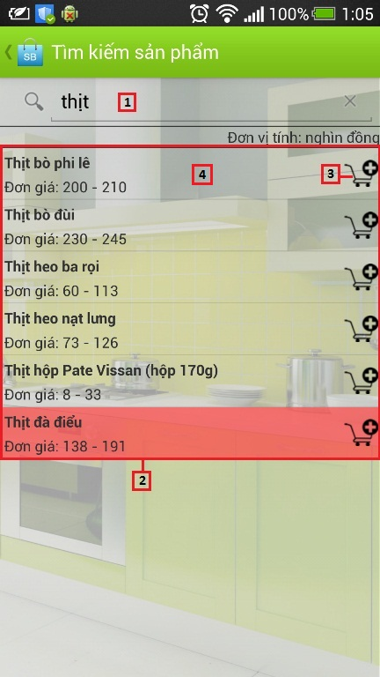

|  |  |
| --- | --- |
| **Step** | **Description** |
| 1 | Fill search key |
| 2 | View search product result list (product name, price) |
| 3 | Click icon  to add product to cart |
| 4 | Click on row to propose price |

* 1. **Propose product price**

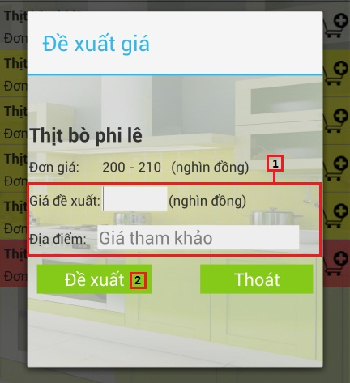

|  |  |
| --- | --- |
| **Step** | **Description** |
| 1 | Fill propose price and market name |
| 2 | Click button “Đề xuất” |

* 1. **View cart**

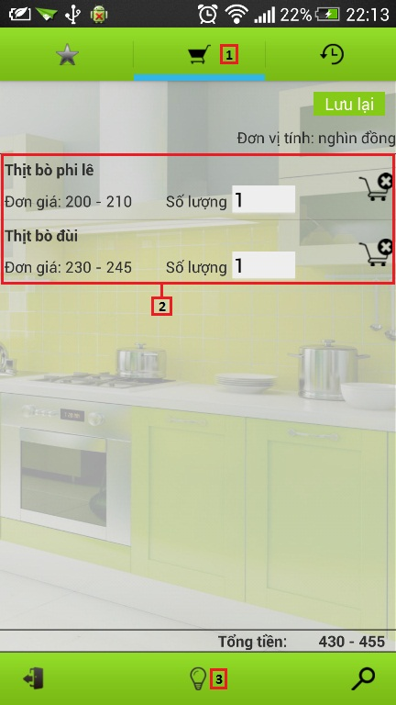

|  |  |
| --- | --- |
| **Step** | **Description** |
| 1 | Click icon  to view cart |
| 2 | View cart info (product name, price, quantity) |
| 3 | Click icon  to view suggest route |

* 1. **View suggest route**

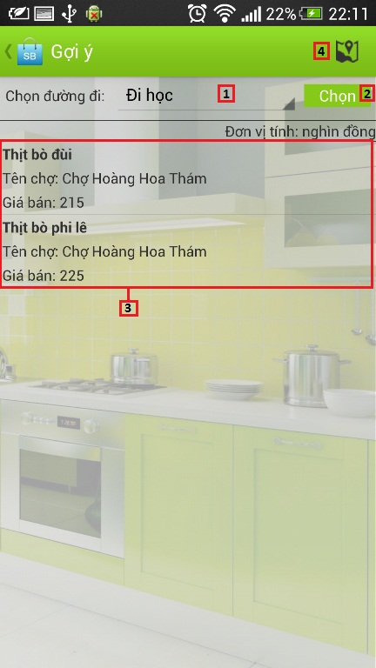

|  |  |
| --- | --- |
| **Step** | **Description** |
| 1 | Select route |
| 2 | Click button “Chọn” |
| 3 | View suggest route list (product name, market, price) |
| 4 | Click icon  to view map |

* 1. **View maps**

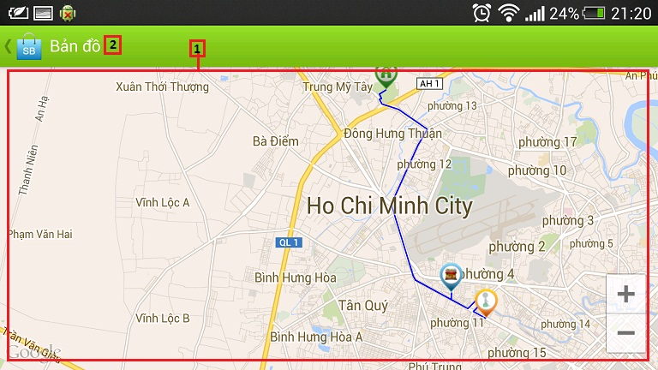

|  |  |
| --- | --- |
| **Step** | **Description** |
| 1 | View maps (suggest route) |
| 2 | Click icon  to back suggest route screen |

* 1. **View history**

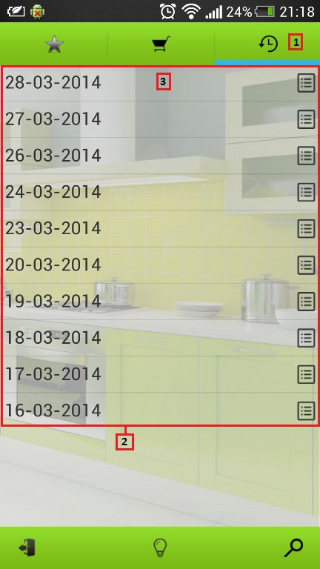

|  |  |
| --- | --- |
| **Step** | **Description** |
| 1 | Click icon  to view history |
| 2 | View history list (date saved) |
| 3 | Click on row to view history detail |

* 1. **View history detail**

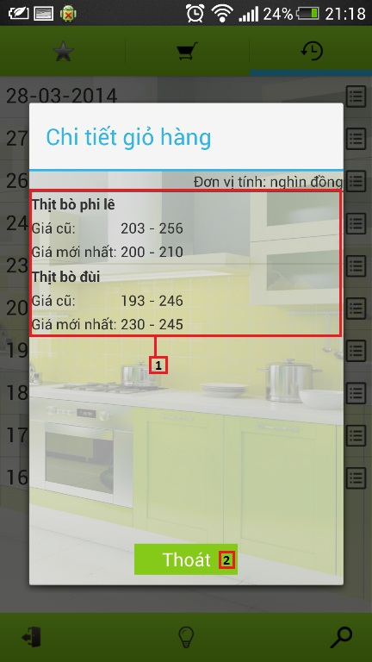

|  |  |
| --- | --- |
| **Step** | **Description** |
| 1 | History detail list (product name, old price, new price) |
| 2 | Click button “Thoát” to cancel |